BOARD OF STUDIES (BOS) REPORT
Government Degree College, Chintapalli
Alluri Sitarama Raju District
Academic Year: 2025–2026

Introduction
The Board of Studies (BoS) of Government Degree College, Chintapalli plays a crucial role in maintaining academic standards and ensuring quality education.
The BOS is responsible for curriculum development, syllabus revision, introduction of new courses, and aligning academic programs with current trends and employment needs.
The BOS meeting for the academic year 2025–2026 was conducted to review and strengthen the curriculum for various undergraduate Honours and conventional degree programs offered in the institution.
Objectives of BOS
The main objectives of the Board of Studies are:
- To review and update the syllabus as per current academic and industry requirements
- To introduce skill-oriented and value-added courses
- To enhance employability and practical knowledge of students
- To recommend suitable textbooks and reference materials
- To improve teaching-learning and evaluation methods
- To ensure implementation of outcome-based education
Courses Covered under BOS
The BOS reviewed the syllabus and curriculum for the following programs:
Arts (BA Honours)
- BA Honours in History
- BA Honours in Economics
Commerce (Honours)
- BCom (Computer Applications)

Science (BSc Honours)
- BSc Honours in Botany
- BSc Honours in Zoology
- BSc Honours in Chemistry
- BSc Honours in Computer Science

Composition of BOS

The Board of Studies consists of the following members:
- Chairperson: Dr.M. Vijaya Bharathi, principal
- Members:
- Dr.M. Srinivasa patrudu -- Department of Economics
- Dr.V. Ramana - -- Department of Zoology
- K. Leela Pavani -- Department of Computer science
- K. Santhosi -- Department of Chemistry
- Dr.D. Kejiya -- Department of English
- I.Raveendra Naik -- Department of chemistry
- G, Jagadees babu -- Department of Political Science
- V.Eswara rao -- Department of commerce
- K. Purna Rao -- Department of Botany
- K. Nageswara rao -- Department of History
- P.u.v. Satish -- Department of Tourism and travel management
- T.B.V.V.S. Prasad -- Department of Computer Applications
- S.R. Srinivasa Raju -- Department of English
- P. Mayuri -- Department of Economics
- K. Sravani -- Department of Physics
- P. Ramaraju -- Department of Commerce
- Sarath -- Department of Computer Science
- T. Uma -- Department of Zoology
- V.V. Ramana -- Department of Mathematics
- K. sivaram kumar -- Physical Director
- T.Jagathrai -- Librarian

BOS Meeting Details
- Date of Meeting: 11-10-2025
- Venue: Government Degree College, Chintapalli
- Time: 11:00 AM
- Departments Involved: Arts, Commerce, and Science
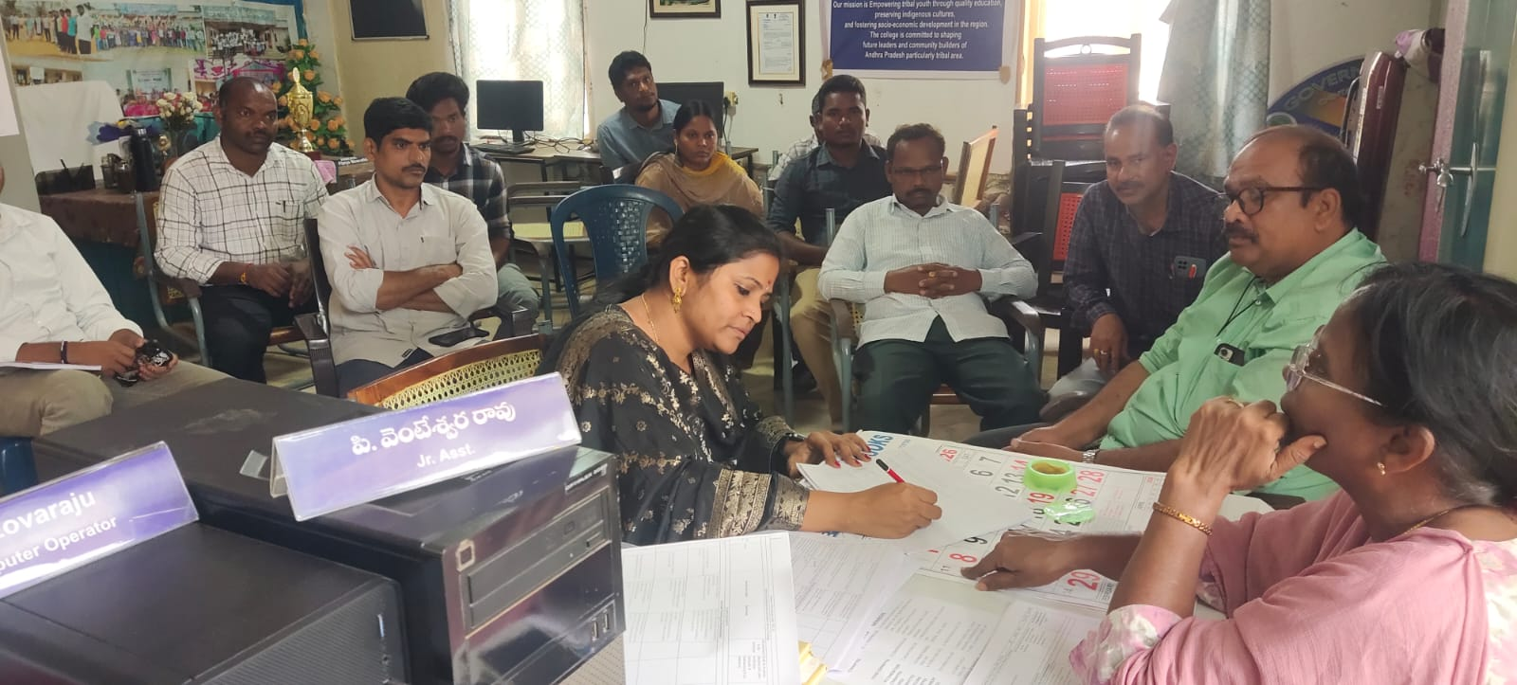
Agenda of the Meeting

The following agenda items were discussed:
- Review and approval of existing syllabus
- Revision of curriculum under Honours system
- Introduction of certificate/value-added courses
- Improvement of teaching-learning methods
- Modification of internal and external evaluation patterns
- Preparation of model question papers
- Discussion on skill development and employability

Proceedings and Discussions
The BOS members actively discussed various academic aspects:
- The existing syllabus of all courses was reviewed in detail
- Emphasis was given to skill-based and outcome-based education
- Suggestions were made to include practical, field-based, and project work
- Updated content was proposed to match current academic and industry trends
- For science courses, more focus was given to laboratory skills and experiments
- For commerce and arts, importance was given to analytical and conceptual learning
Resolutions Passed
After detailed discussions, the following resolutions were unanimously passed:
- The syllabus for all courses (BA Honours, BCom, BSc Honours) was reviewed and approved
- Minor revisions were suggested in selected subjects to enhance clarity and relevance
- Introduction of certificate courses in skill development areas was approved
- Inclusion of project work, assignments, and seminars as part of continuous evaluation
- Updated evaluation pattern with internal and external assessments was approved
- Preparation and approval of model question papers
- Emphasis on student-centric and participatory learning methods
Course-wise Highlights
BA Honours (History & Economics)
- Inclusion of contemporary topics and current affairs
- Focus on analytical thinking and socio-economic issues
- Encouragement of seminars and presentations
BCom (Computer Applications)
- Integration of computer skills with commerce subjects
- Focus on practical applications like accounting software
- Skill development in digital and financial literacy

BSc Honours (Botany, Zoology, Chemistry, Computer Science)
- Emphasis on laboratory work and practical experiments
- Introduction of project-based learning
- Updated syllabus with recent scientific developments
- Computer Science includes programming and IT skills
Implementation
The recommendations and approved syllabus of the BOS will be implemented from the academic year 2025–2026. All faculty members are instructed to follow the revised curriculum and adopt innovative teaching methods.
Departments will maintain proper records of lesson plans, assignments, and student performance as per BOS guidelines.
Outcome of BOS
The BOS activities resulted in:
- Improved curriculum quality
- Enhanced student learning outcomes
- Better alignment with employment opportunities
- Strengthened academic standards
- Increased focus on skill development
Conclusion
The Board of Studies has significantly contributed to the academic development of Government Degree College, Chintapalli. The revised curriculum and academic strategies will help students gain knowledge, skills, and competencies required for higher education and employment.
The institution remains committed to continuous improvement in academic excellence through effective BOS functioning.

